# **Guidelines (from the “**[**Instructions for Authors**](https://media.springer.com/full/springer-instructions-for-authors-assets/pdf/1493773_176839624_SMST%20Author%20Guidelines.pdf)**”)**

Length:

* Approximately 8 pages (e.g., 4,000 words)

Format:

* Word files with only essential formatting (bold, italic, etc.).
* Tables and figures should be included separately after the reference section.
* High quality art should be included as separate files (1200 DPI .tif ☹).

# **Notes**

Draft titles:

1. Shape Memory Alloy Constitutive Model Calibration via an Open-Source Graphical User Interface
2. SMA-REACT: Shape Memory Alloy Rendering of Experimental Analysis and Calibration Tool

Keywords:

1. Constitutive Modeling
2. Optimization
3. Experimental analysis
4. Calibration

Points to highlight in the cover letter:

* This work applies to the following topics outlined in the Author Instructions:
  + 5) Solutions of shape memory problems in industry
  + 10) Alloy design to tailor the properties to achieve shape memory materials with improved functionality in applications
* This is a new interpretation of an existing problem. We aim to reduce costly barriers in the material design -> material fabrication -> structural design -> structural fabrication cycle by enabling high-throughput material model calibration.

# **Outline**

1. **Introduction (1-1.5 pages)**
   1. **Describe the process of designing with SMAs (figure 1)**

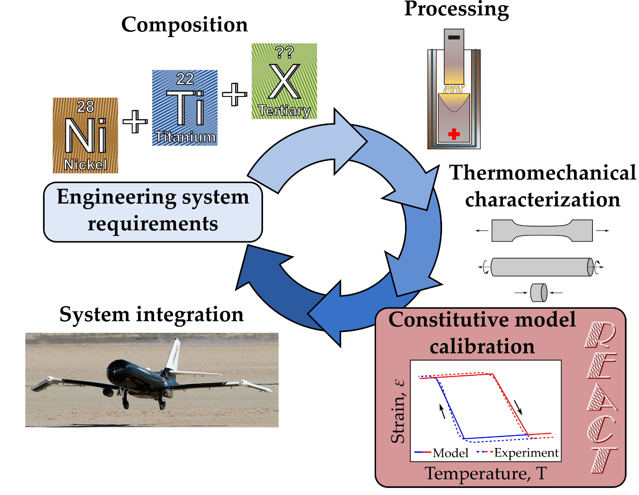

Figure 1: The typical SMA development process involves many discrete steps. This work provides an easy constitutive model calibration tool (box 5) to enable SMA component design.

* + 1. The process of going from composition-processing-material properties is very well documented (cite Othmane) and there are tools that allow people to search for different properties as a function of material constituents.
    2. Traditionally, each stage of the process takes a decent amount of time for a specific engineered component, and each stage potentially involves a feedback loop to the start to refine the material.
    3. Different people typically do the top and bottom. The materials engineers (like Othmane) produce a great material (and potentially train it), and then the design engineers characterize it for their particular application (tension/compression/shear), produce a calibrated constitutive model, and design a component with that model.
    4. Sometimes, the engineered component design comes first and specifies the particular material properties that are needed for performance (cite the radiator or other things, maybe CASMART?)
    5. This work focuses on an open-source tool that allows quick calibrations to be found from existing experimental data, because one of the main bottlenecks is learning the complex constitutive models. We focus on the lagoudas SMA model due to its use and due to the authors’ familiarity with it, but the same tool could be adapted for a wide range of other models (cite Brinson, etc.). (*should I add an appendix to outline the steps to do a different model?)*
    6. We also focus on constant force thermal cycling, as existing tools (abaqus) do a fine job for superelasticity.
  1. What is SMA Constitutive Model Calibration?
     1. Mathematically, calibration minimizes error between constitutive model predictions and experimental data subject to physical constraints (e.g., conservation laws) by varying model parameters.
  2. Why is model calibration important?
  3. How have people performed model calibration in the past?
     1. Reference a handful of papers.
        1. Optimization methods [1]–[4]
        2. Analytical methods [5], [6]
        3. “Shoot from the hip methods” (e.g., underreported procedures)
           1. References: [7], [8]
  4. What are the drawbacks of these methods?
     1. Large amount of tuning required -> leads to difficulties reproducing
     2. Large amount of tribal knowledge (“one skilled in the art”)
     3. No open source methods exist in literature
        1. Cite NASA’s tools that exist for property extraction/databasing.
           1. ASMADA: Automated extraction of ASTM standard properties [9]
           2. SM2ART: Graphical interpretation of the relationship from composition, processing, and properties. [10], [11]
           3. Other calibration GUIs:

COMPARE (Constitutive Material PARameter Estimator) – Viscoplasticity [12]

Developed by NASA Glenn

Abaqus’ material calibration toolset

Works for Superelastic SMAs

Need citation.

* + - 1. Maybe a figure here showing the development process and how our tool fills a missing link? Idk we’re somewhat figure-light right now.
  1. Thesis statement
     1. This work provides a vital link between materials scientist and SMA design engineer that has previously been accomplished by custom in-house tools and large amounts of tribal knowledge
        1. The link between composition, processing, and properties is well studied
     2. We focus on the temperature-driven Lagoudas 1-D constitutive model, but the methods and accompanying software described herein can be easily extended to consider other constitutive models, higher dimensional models (e.g., 3D models with anisotropic effects), and different loading modes (e.g., superelasticity).

1. **Method description (3-4 pages)**

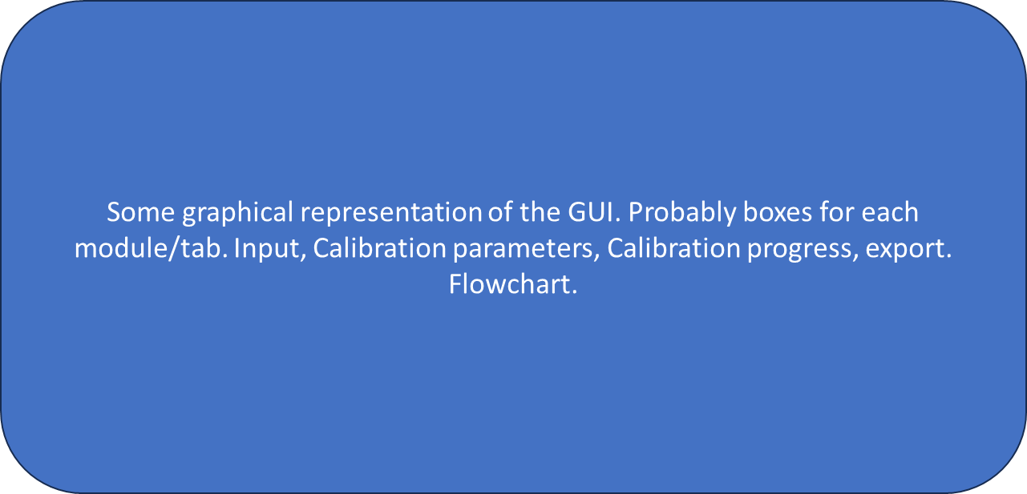

Figure 2: SMA-REACT allows the user to load their own data, specify known model parameters, and find an optimal calibration that best approximates experimental response.

* 1. Flowchart describing the different components.
     1. Pre-processor
        1. Data I/O
           1. Inputs: files, units (outputs -> T,eps,sigma as a function of time)
        2. Filtering
        3. Plotting
        4. Anything else
     2. Model calibration
        1. Property initialization
           1. Inputs: free variables x, known variables y, bounds, optimization parameters (no outputs)
        2. Optimization methods selection
     3. Post-processor
        1. Plotting
           1. no user inputs (outputs -> plots of optimization progress, phase diagram, strain-temperature plots, exported solution)
        2. Property export
  2. Pre-processor
     1. Jacob, fill this section out please.
     2. What format does the file need to be in? How adaptable/flexible is this?
        1. Cite Kuner’s work here because we ripped his code.
  3. Model calibration
     1. Brief description of the Lagoudas 1D model.
        1. Why 1-D?
        2. Why Lagoudas actuator model?
        3. What are the unknown parameters (e.g., design variables)?

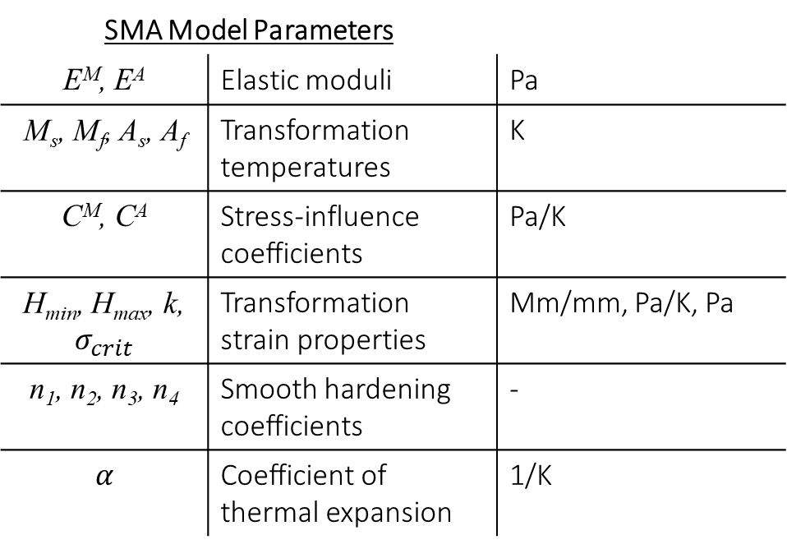

Table 1: The Lagoudas SMA constitutive model requires calibration of 17 unique (but dependent) parameters.

* + 1. Describe each parameter and its effect on the phase diagram/strain-temperature cycles
       1. E_M/E_A = Moves the tails of the strain-temperature plots vertically.
       2. TTs = moves the transformation regions/surfaces horizontally.
       3. C_A/C_M = Defines the slopes of the transformation surfaces in the phase diagram. Defines how the transformation temperatures change as a function of stress. Low Cs means the transformation temperatures change a lot with increasing stress.
       4. H_cur = defines the transformation strain as a function of stress. The vertical distance of the hysteresis.
       5. N_i = defines the smoothness of transformation. Has an interplay with transformation temperatures (see next figure)
       6. Alpha = defines the slope of the tails on the strain-temperature plots. Note that for this model reduction, we assume one coefficient for thermal expansion for simplicity.
    2. Need for numerical optimization
       1. The need to numerically optimize the material properties comes (in part) from the fact that transformation temperatures and smooth hardening coefficients are related.
       2. Transformation temperatures are mathematically as the onset of nonlinearity (i.e., when the current material state exceeds the transformation surface). A decreasing smooth hardening coefficient alters the point at which nonlinearity occurs, changing the transformation temperatures.
       3. One could not find the transformation temperatures via the tangent method (as is defined in the ASTM standard) then iterate to find the optimal smooth hardening coefficients.
          1. Mention that the model-defined transformation temperatures are not necessarily equal to the ASTM standard reported transformation temperatures due to this difference in definition.

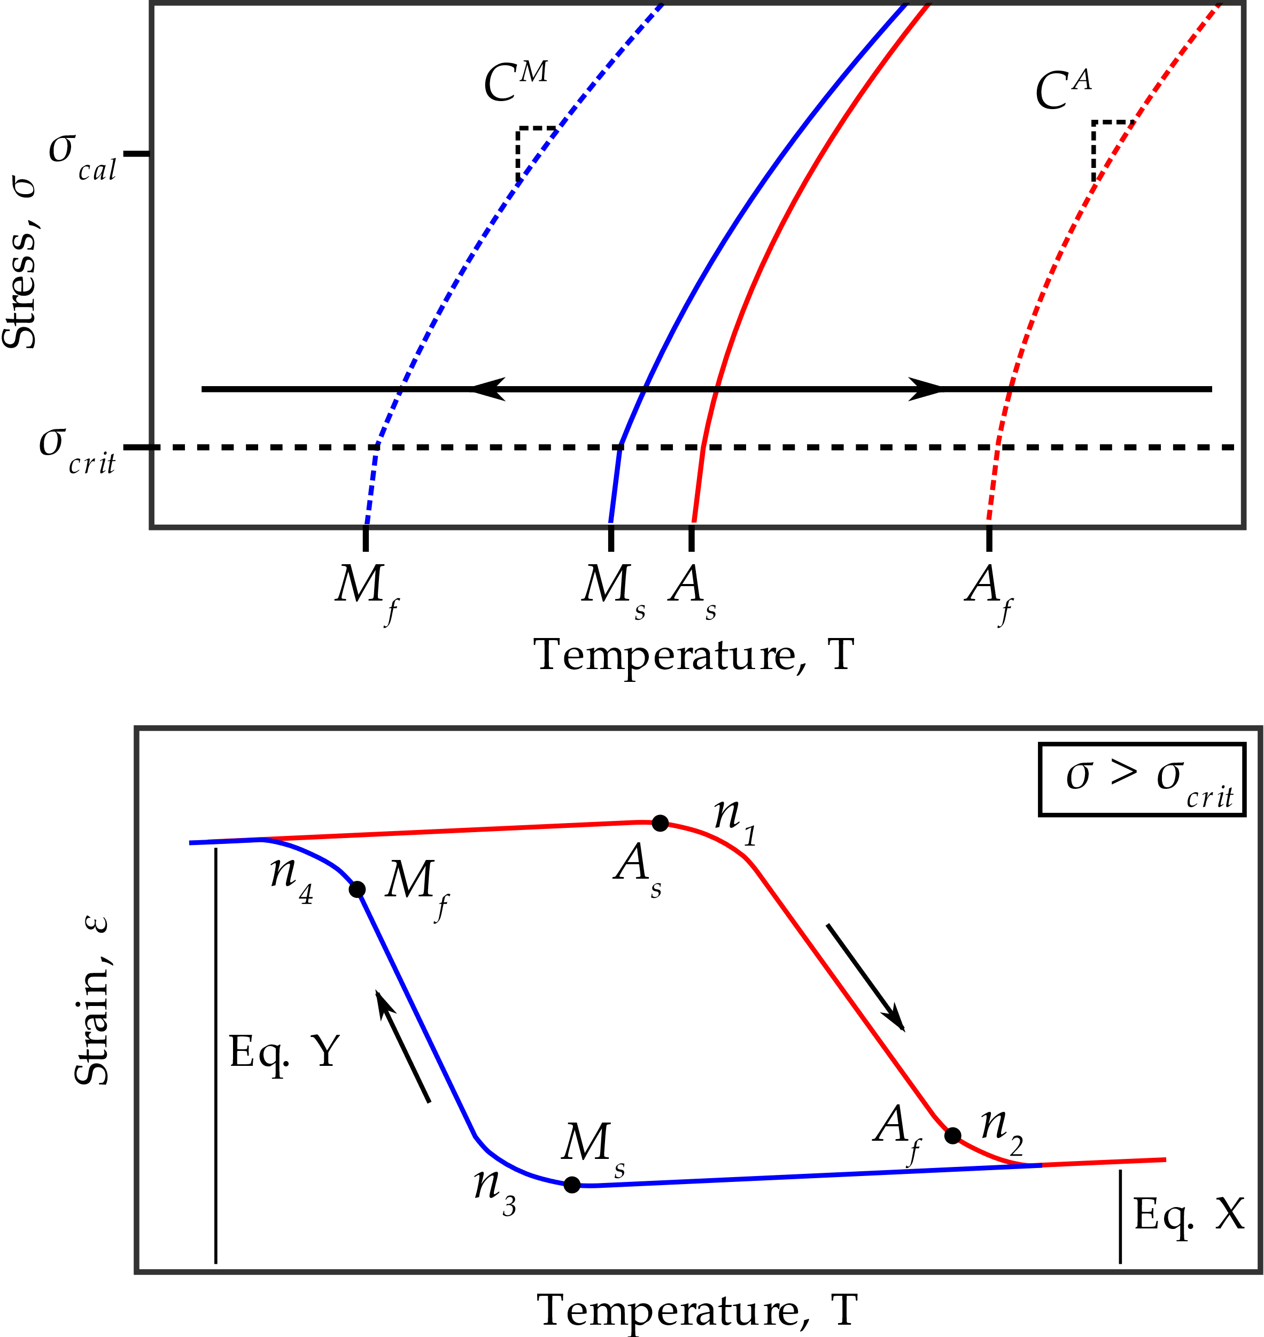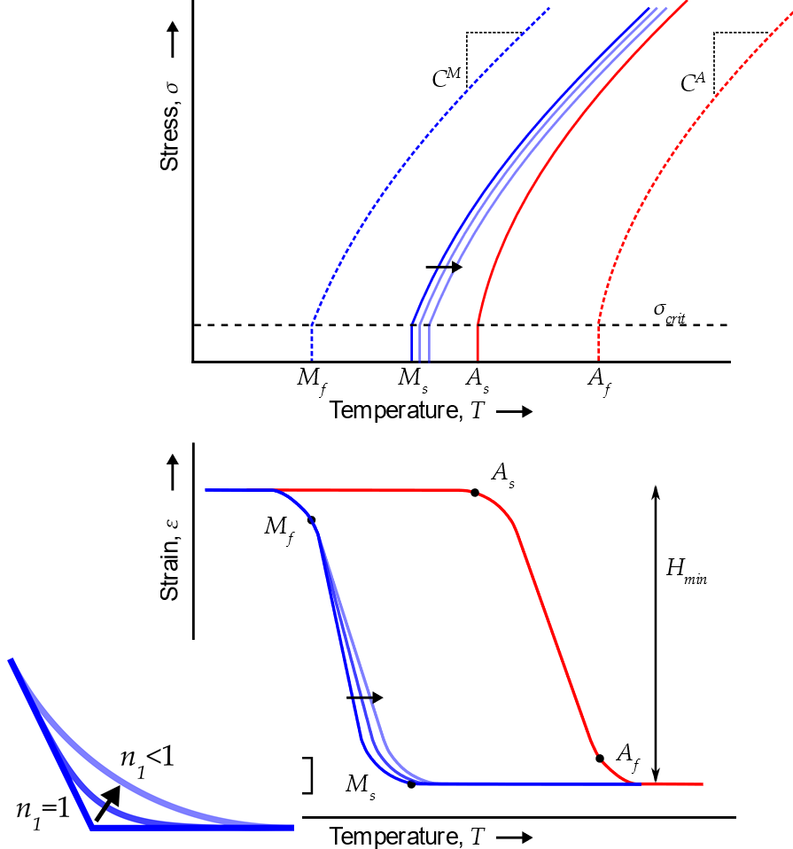

Figure 4: Due to the interdependence of model parameters, numerical optimization is required for a robust fit of experimental data.

* + 1. Brief optimization description
       1. What is Hybrid optimization?
  1. Post-processor
     1. Outputs. Describe it a little bit.
     2. Jacob, this would be where your input would help.

1. **Implementation Example (2 pages)**
   * 1. Data source description [14]
        1. Data was used because:
           1. Quality and quantity of data.
           2. Representative/relevant material system (cite a bunch of NiTiHf papers).
           3. Non-zero coefficient of thermal expansion.
           4. Nonlinear relationship between applied stress and transformation strain.

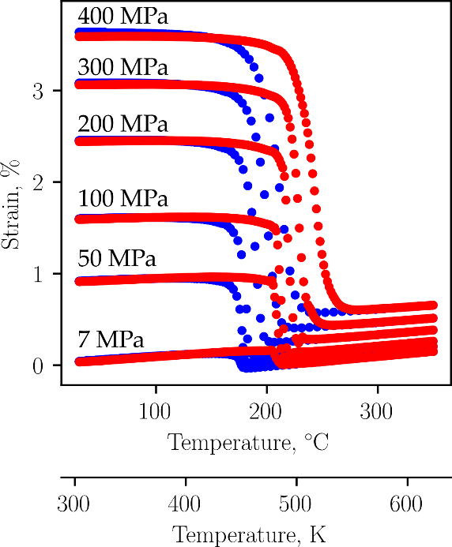

* 1. Traditional/person-in-the-loop calibration
     1. Hooke’s law to find E_A
     2. Hooke’s law to find E_M, alpha, H_cur(sigma)
     3. Transformation temperatures calculated from tangent method
     4. C_A, C_M from transformation temperatures at multiple stresses.
     5. Set n_i = 1
  2. Traditional calibration result

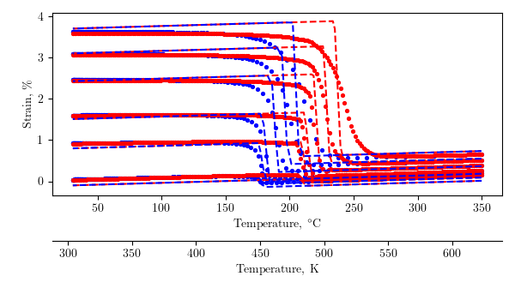

Figure 5: Conventional analytical/numerical calibration techniques produce a passable solution, but rely on user iterations to fine-tune model response.

* + 1. This calibration produced a solution with 3.13% error, but clearly there is performance that is left on the table.
    2. Additionally, this calibration required numerical optimization to find the properties in step 2, so a globally optimal calibration is needed.
    3. Also the response is only fit to the points at which Hooke’s law was used. Subject to user input and not guaranteed to best capture the entire response.
  1. Optimization using the SMA-REACT GUI

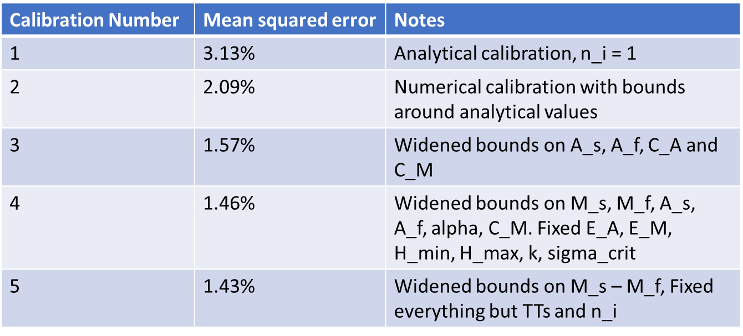

Figure 6: The SMA-REACT tool allows further refinement of the calibrated solution.

* + 1. With the tool, by inspecting the bounds to which the design variables converged, bounds can be fine-tuned and a truly globally optimal solution can be found.
    2. These 4 calibrations were completed in a matter of minutes, and accuracy was doubled.
  1. Final optimized result

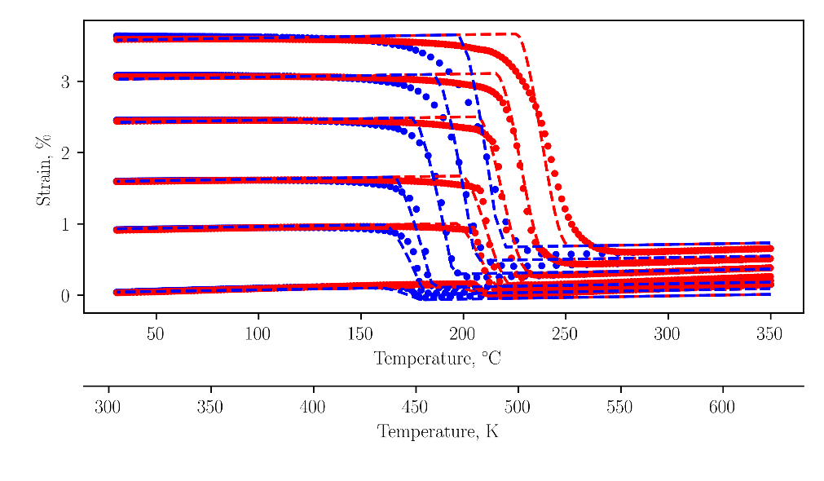

Figure 7: The final calibration agrees with the experimental data to within 1.5% mean squared error.

1. Good
   1. The response in martensite is almost perfectly captured.
   2. Transformation temperatures are captured quite well. This gets worse with increasing stress because 1) the transformation temperatures are not a linear function of stress (see C_ figure in Bigelow), and 2) the smoothness of transformation is not constant with stress (see 100 MPa transformation into austenite vs. 300 MPa transformation into austenite).
   3. You can see how the optimizer finds the best global fit of the data when you look at the transformation temperatures with respect to austenite. For lower stresses, the A_s is too early, and the A_f is too late. At intermediate stresses, like 100 and 200 MPa, the transformation temperatures are almost perfect. Then, at 300 MPa, the A_s is too late and the A_f is too early. This could be better fit at the relevant stresses by biasing the solution to prioritize fitting certain stress levels (see my paper) or by simply calibrating the model at the stress levels that matter most.
2. Bad:
   1. The response in austenite isn’t perfect. It under-predicts the elastic strain at low stresses, then over-predicts it at high stresses. This is probably due to the transformation strain as a function of stress not being perfectly captured by the exponential function. It speaks to the utility of using an optimized result, because the solution is a best-case fit with no constant offset.
   2. The coefficient of thermal expansion is not constant for austenite and martensite. Clearly, the coefficients of thermal expansion in austenite is larger than that in martensite. This is a model deficiency because the current model uses a convex cutting plane assumption for numerical integration/return mapping. Could be corrected.
3. **Conclusions and Further Refinements (1 page)**
   1. Conclusions
      1. Highlight open source nature
      2. Highlight speed of going from experimental data to constitutive model parameters.
      3. Where can this be used?
         1. Abaqus UMAT
         2. Other commercial FEA software.
   2. Further Refinements
      1. Alternative loading modes
         1. Superelasticity
         2. Combined superelasticity/shape memory (cite Pedro’s robot work).
      2. Alternative constitutive models
         1. Cite a handful here… there are plenty.
            1. Highlight that it only requires changing the input parameter structure and the model function – two things that are very easy for someone well versed in implementing constitutive models.
      3. Anything else?